**NoSQL (Customer Database)**

**Question**

**(week-09)**

1. Create a collection by name Customers with the following attributes.Cust_id, Acc_Bal, Acc_Type

2. Insert at least 5 values into the table

3. Write a query to display those records whose total account balance is greater than 1200 of account type ‘Z’ for each customer_id.

4. Determine Minimum and Maximum account balance for each customer_id.

5. Export the created collection into local file system

6. Drop the table

7. Import a given csv dataset from the local file system into mongodb collection.

**Create Table:**

db.**createCollection**("Customer");



# Inserting values into the table.

db.Customer.insertMany([{custid: 1, acc_bal:10000, acc_type:"Saving"},

{custid: 1, acc_bal:20000, acc_type: "Checking"},

{custid: 3,acc_bal:50000, acc_type: "Checking"},

{custid: 4, acc_bal:10000,acc_type: "Saving"},

{custid: 5, acc_bal:2000, acc_type: "Checking"}]);

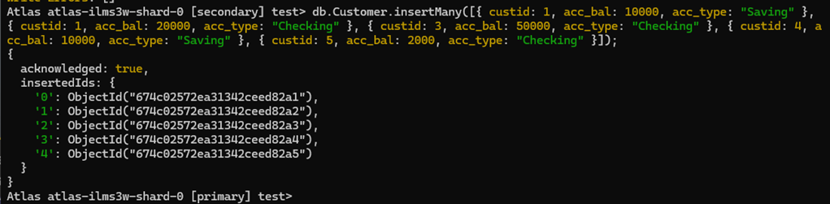

# Queries

Finding all checking accounts with balance greater than 12000

db.Customer.find({acc_bal: {$gt: 12000}, acc_type:"Checking"});

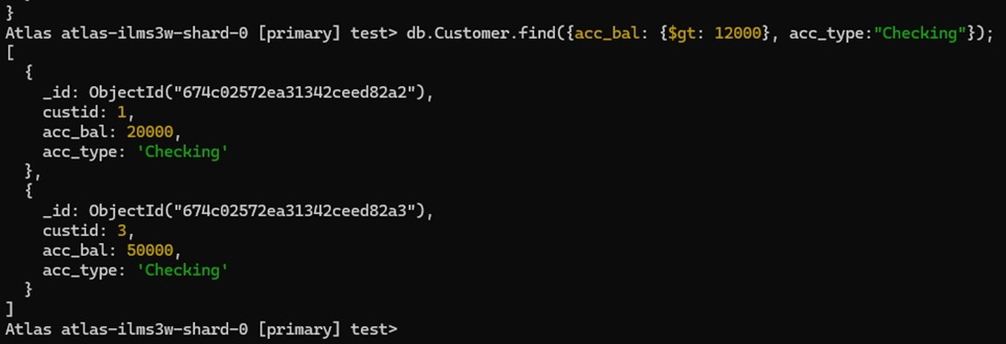

**Finding the maximum and minimum balance of each customer**

db.Customer.aggregate([{$group:{_id:"$custid", **minBal**:{$min:"$acc_bal"}, **maxBal**:{$max:"$acc_bal"}}}]);

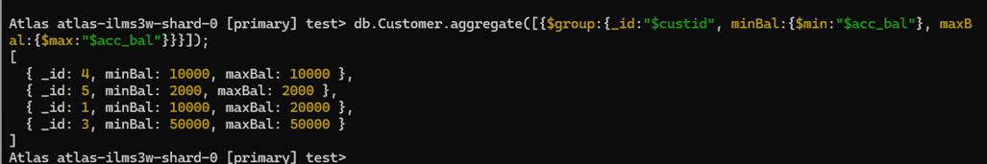

### Dropping collection “Customer”

db.Customer.drop();

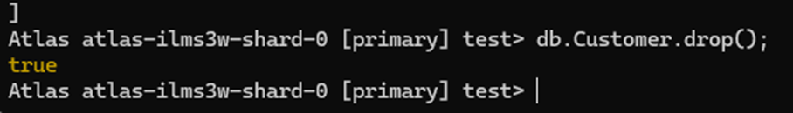

### Exporting the collection to a json file

mongodb+srv://architavcs23:<db_password>@cluster0.memuu.mongodb.net/--collection=Customer-- out C:\Users\vijay\Documents\test.Customer.json

### Exporting from a json file to the collection

mongodb+srv://architavcs23:<db_password>@cluster0.memuu.mongodb.net/--collection=Customer-- out C:\Users\vijay\Documents\test.Customer.json

db.Customer.find();

